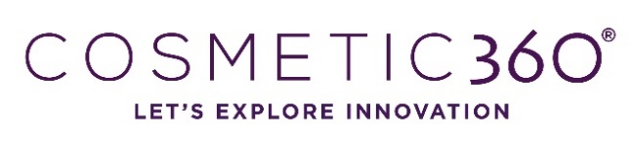
Call for conference – Cleantech

Please fill in this document and send it before 31/05/2023 to Julien ROMESTANT – jromestant@cosmetic-valley.com

COSMETIC 360, the international innovation fair for cosmetic and perfume industry, will be organized on 18th and 19th of October 2023 in Paris. During this fair, conferences will be organized on the subject of Cleantech.

Name
Email

Function

Name of the company or research unit

Email

CONFERENCE

Conference theme
Please choose the theme corresponding to your conference subject
      - Cleantech trends : consumer, trends, brands
      - Cleantech packaging : refill, carbon offset, carbon neutral…
      - Industry decarbonation : net zero production, carbon positive
      - Cleantech ingredients : eco regeneration, short supply, upcycling…
Title of your conference
Precise the title of your conference
Key-words
Precise 5 key words about your conference subject
Summary of the conference
Please describe in a few lines the context (in case of a conference with several, indicate it)

Photography of the speaker, to join at the application.

