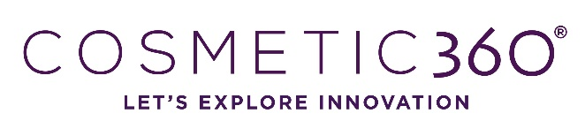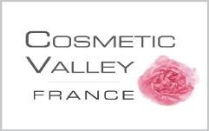
Call for conference – Artificial Intelligence & Cosmetic

Please fill in this document and send it before 10/07/2022 to Fanélie SAUVAGERE fsauvagere@cosmetic-valley.com

COSMETIC 360, the international innovation fair for cosmetic and perfume industry, will be organized on 12th and 13th of October 2022 in Paris. During this fair, 4 conferences will be organized on the subject of Artificial Intelligence.

Name
Email

Function

Name of the company or research unit

Email

CONFERENCE

Conference theme
Please choose the theme corresponding to your conference subject
      - Artificial Intelligence and Social Acceptance
      - Artificial intelligence and environmental data
      - Artificial intelligence and marketing
      - Artificial intelligence and industrial performance
Title of your conference
Precise the title of your conference
Key-words
Precise 5 key words about your conference subject
Summary of the conference
Please describe in a few lines the context (in case of a conference with several, indicate it)

Photography of the speaker, to join at the application.

